**Adding client to Satellite:**

rpm -Uvh <http://ylmgp060/pub/katello-ca-consumer-latest.noarch.rpm>

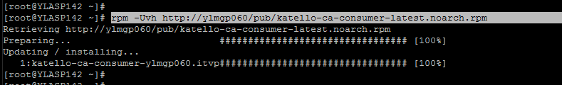

subscription-manager register --org="ITV_CORPORATE" --activationkey="SatelliteKey2018"

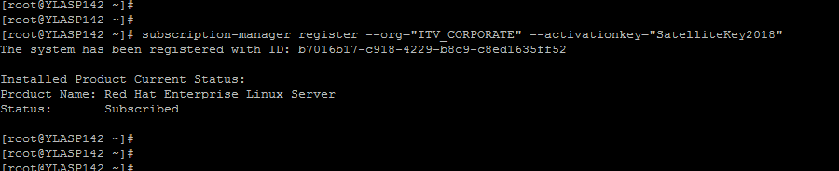

Check if the server is now seen on Satelliate server

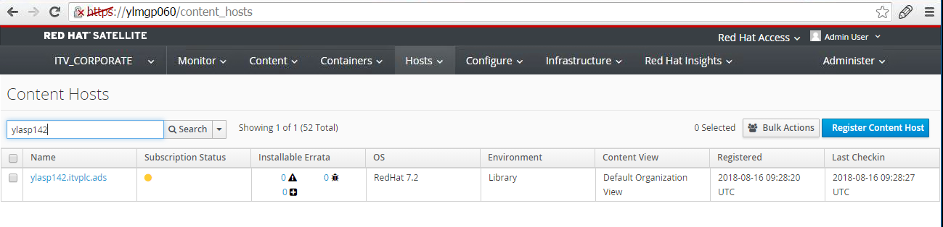

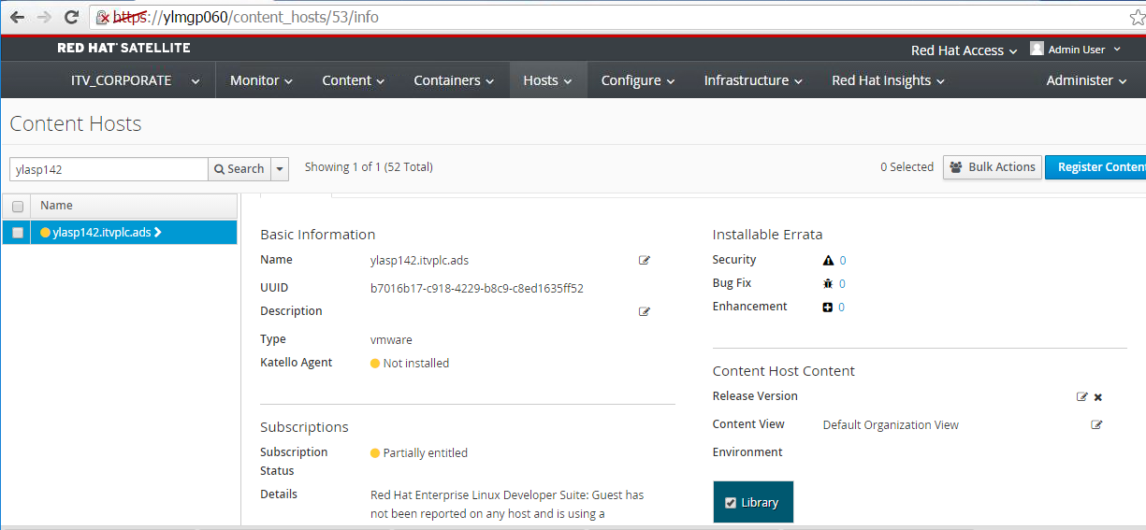

subscription-manager repos –list

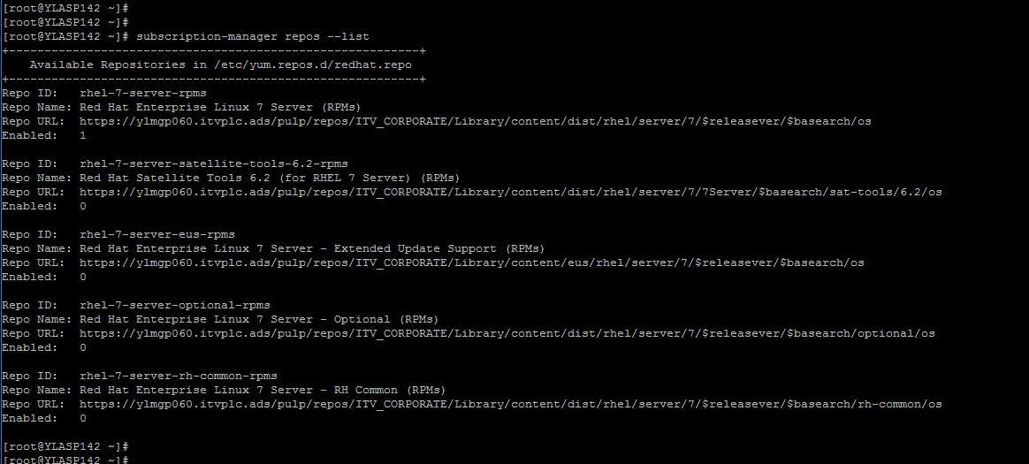

subscription-manager repos --enable=rhel-\*-satellite-tools-\*-rpms

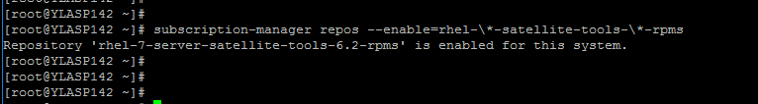

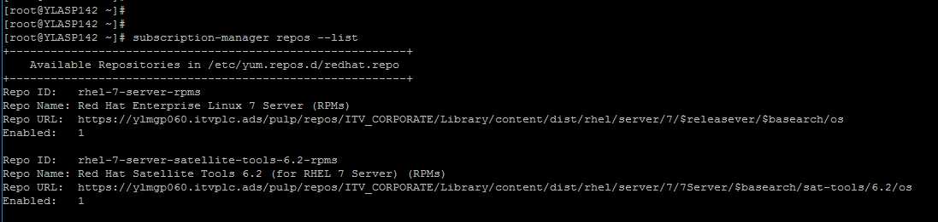

yum -y install katello-agent

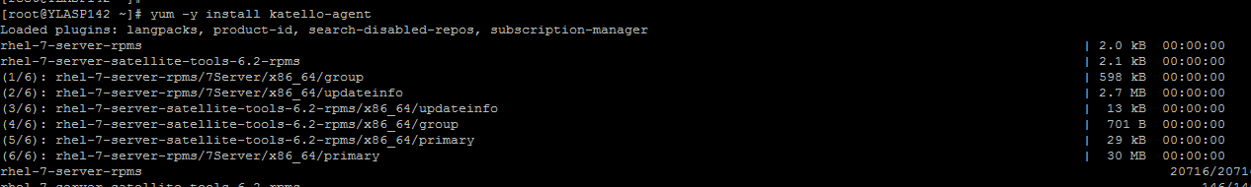

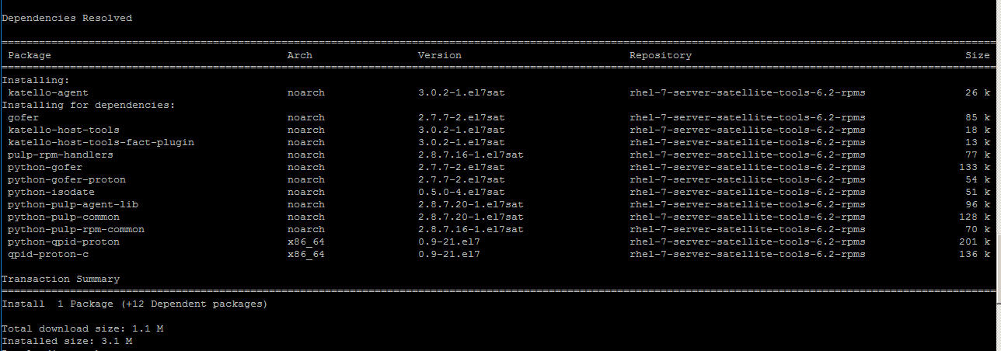

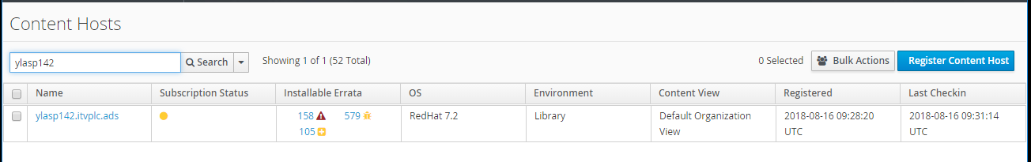

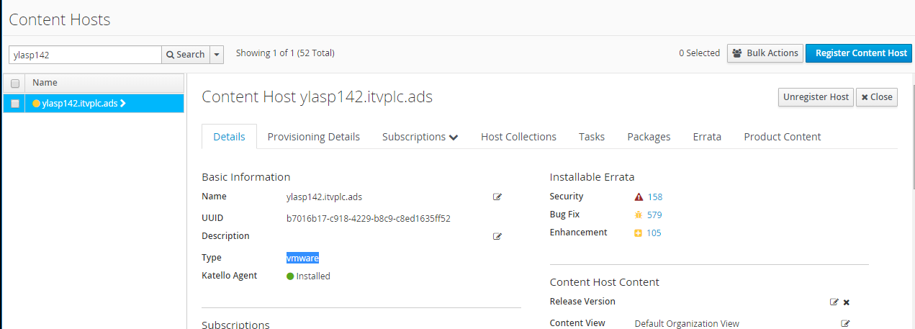

**Troubleshooting steps if we face repository sync issue:**

# foreman-rake foreman_tasks:export_tasks TASK_SEARCH='' TASK_DAYS=3

Please provide output of below commands from satellite server:

# hammer ping

# katello-service status

As per the task export, there are some tasks which are in pending state.

Please provide output of below command to check if there is any task which is in paused state on satellite server:

# sudo su - postgres -c "psql -d foreman -c 'select label,count(label),state,result from foreman_tasks_tasks where state <> '\''stopped'\'' group by label,state,result ORDER BY label;'"

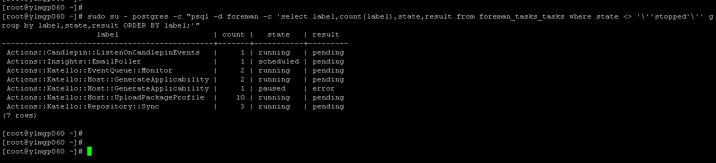

As per output which you have shared, there is one task which is in paused state. Please try to stop this paused task with below commands:

# service foreman-tasks stop

# foreman-rake console --> (Please wait to get it load)

ForemanTasks::Task.where(:label => "Actions::Katello::Host::GenerateApplicability", :state => "paused").map { |task| task.update_column(:state, "stopped") }

exit --> (to come out of foreman console)

# service foreman-tasks start

Then try to run the below command to restart pulp related services:

# for i in pulp_celerybeat pulp_resource_manager pulp_workers; do service $i restart; done

Now, confirm that all the services are up and running:

# hammer ping

# katello-service status

